ASSIGNMENT 9

<project xmlns=*"http://maven.apache.org/POM/4.0.0"*

xmlns:xsi=*"http://www.w3.org/2001/XMLSchema-instance"*

xsi:schemaLocation=*"http://maven.apache.org/POM/4.0.0 https://maven.apache.org/xsd/maven-4.0.0.xsd"*>

<modelVersion>4.0.0</modelVersion>

<groupId>SeleniumAssignments</groupId>

<artifactId>SeleniumAssignments</artifactId>

<version>0.0.1-SNAPSHOT</version>

<dependencies>

<dependency>

<groupId>org.testng</groupId>

<artifactId>testng</artifactId>

<version>7.4.0</version>

<scope>test</scope>

</dependency>

<dependency>

<groupId>org.seleniumhq.selenium</groupId>

<artifactId>selenium-java</artifactId>

<version>4.0.0-beta-4</version>

</dependency>

<dependency>

<groupId>commons-io</groupId>

<artifactId>commons-io</artifactId>

<version>2.11.0</version>

</dependency>

<dependency>

<groupId>org.apache.poi</groupId>

<artifactId>poi-ooxml</artifactId>

<version>5.0.0</version>

</dependency>

</dependencies>

</project>

Source code:

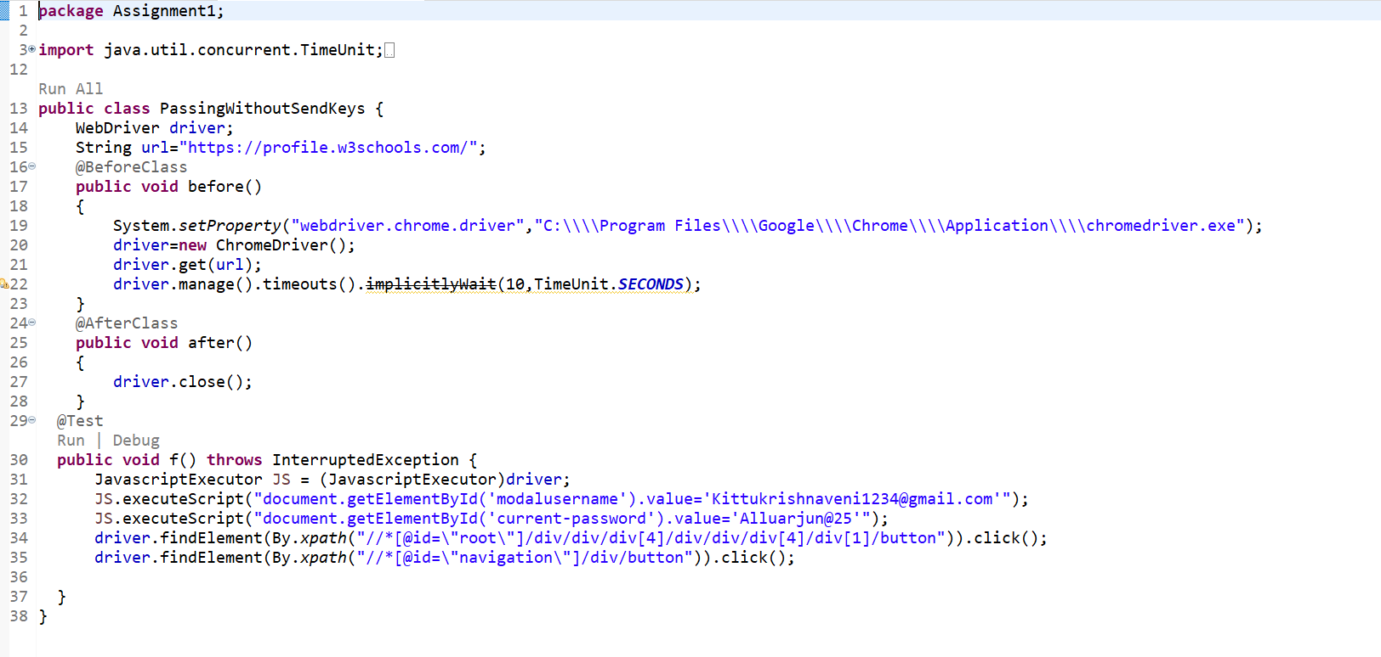

Output:

